**SPH3U: 3.1 Types of Forces**

1. **Measuring forces and force diagrams**

|  |  |
| --- | --- |
| Dynamics: |  |
| force |  |
| newton (N) |  |
| measuring forces |  |
| system diagrams |  |
| free-body diagrams (FBDs) |  |

 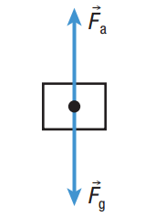

1. **Everyday forces**

|  |  |
| --- | --- |
| Applied force: |  |
| Tension: |  |
| Normal force: |  |
| Friction: |  |
| Gravity: |  |



Draw both the system diagram and the FBD for each object in italics.

1. A *cup* is sitting at rest on a table.
2. A large *trunk* in the basement is pulled by a rope tied to the right side of the trunk by a person. The trunk does not move.
3. A *baseball player* is sliding to the left across the ground.
4. A *desk* is pushed to the left across the floor.
5. **Calculating net forces**

|  |  |
| --- | --- |
| Net force: |  |

The floor exerts a normal force of 36 N [up] on a stationary chair. The force of gravity on the chair is 36 N [down]. Draw the FBD of the chair and use the FBD to determine the net force on the chair.

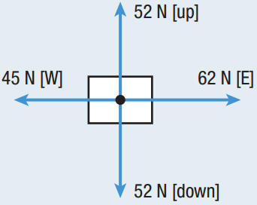The figure to the right shows all the forces acting on an object. Use the FBD to calculate the net force.

1. **Four fundamental forces**

|  |  |
| --- | --- |
| Gravitational: |  |
| Electromagnetic: |  |
| Strong nuclear: |  |
| Weak nuclear: |  |

|  |  |  |  |
| --- | --- | --- | --- |
| **Type of force** | **Approximate relative strength** | **Range** | **Effect** |
| gravitational |  |  |  |
| electromagnetic |  |  |  |
| strong nuclear |  |  |  |
| weak nuclear |  |  |  |

**Homework:** page 122: #1-2, 5, 7, 13, 15